### **Customer Behavior and Insurance Preferences: (KEY FINDINGS)**

Conducted by COCURON Morgane, BROSSIER Léandre, SKANDERI Elyes, FIGARD Clément, EL AYOUBI Hilal, BOURDET Caroline.

#### **General Trends:**

1. **Age and Insurance Preferences:**
   * **35-45 years old** customers are more likely to be the **average age group** purchasing insurance, indicating that this group has the highest representation among customers.

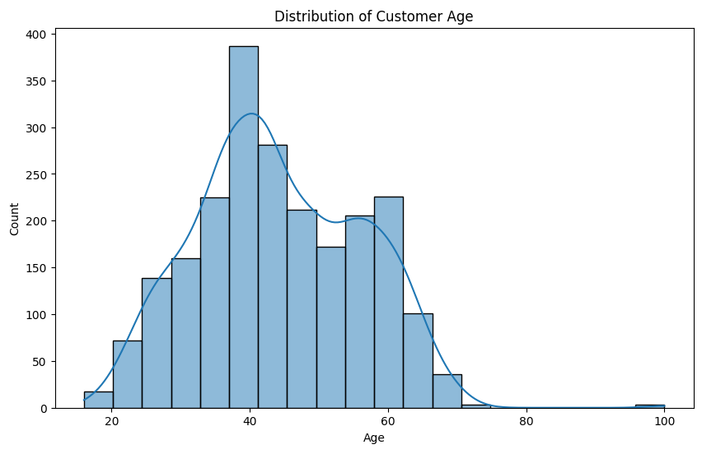

* + **Age 28 to 34** customers are most likely to be interested in **travel insurance**, with a noticeable spike in this demographic’s preference for travel-related policies.

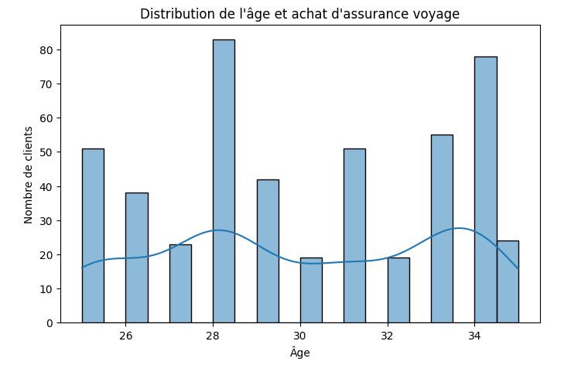

1. **Widowed Customers:**
   * Customers who are **widowed** tend to **spend more** on insurance than other customer segments. This could imply that widowed individuals might be looking for higher levels of coverage or have specific needs that drive higher spending.

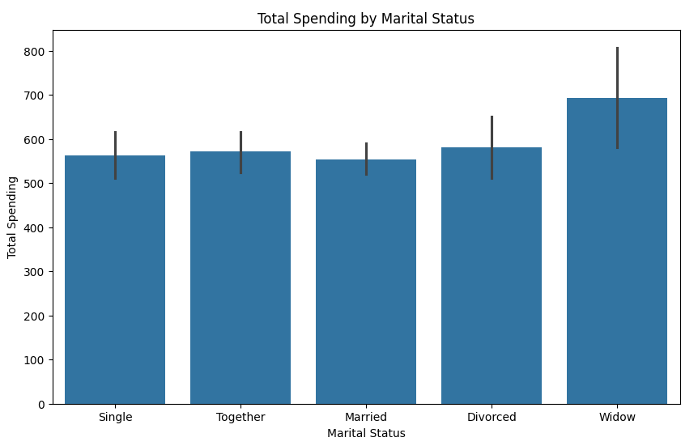

1. **Interest in Eco-friendly Features:**
   * Customers **aged 30-50** tend to show **less interest** in eco-friendly scores than the average customer. This demographic might be less focused on sustainability when making decisions about their insurance.

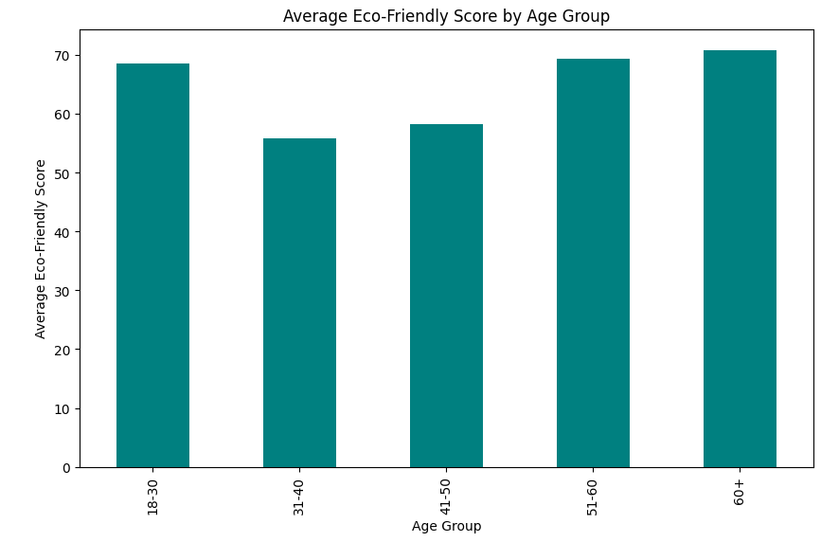

* + On the other hand, **customers with 0 children** tend to be **more concerned** about the eco-friendly scores of the policies, indicating a preference for sustainability, possibly linked to their lifestyle and environmental awareness.

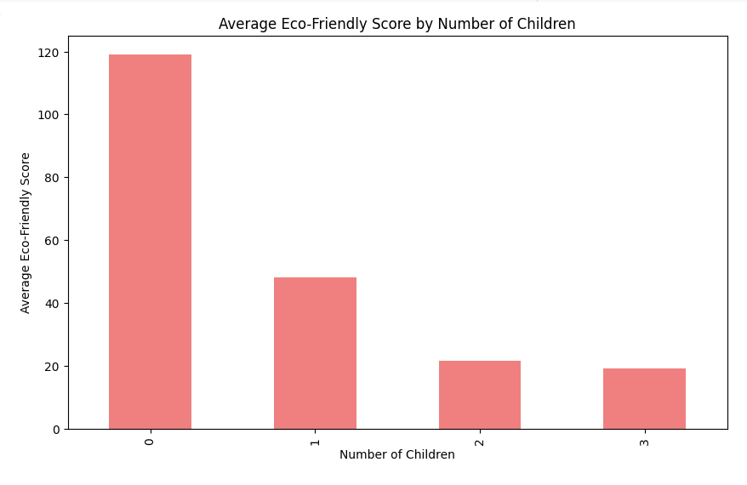

1. **Insurance Preferences by Travel History:**
   * **Customers who have traveled abroad** are more likely to purchase **travel insurance**. This group shows a higher ratio of interest in travel-related policies, which could be because of prior travel experience and the risks they associate with it.

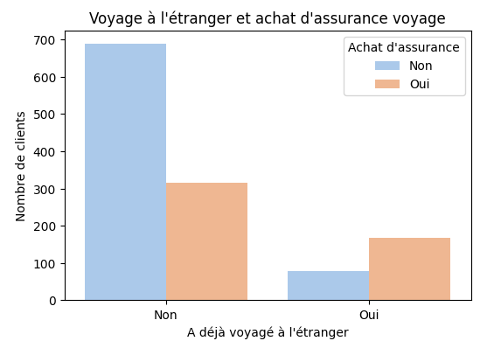

1. **Medical Insurance Preferences by Age and Lifestyle:**
   * Younger customers, particularly in the **18-20 age range**, are more likely to have **medical insurance**. This suggests that younger people may be more proactive about health coverage.

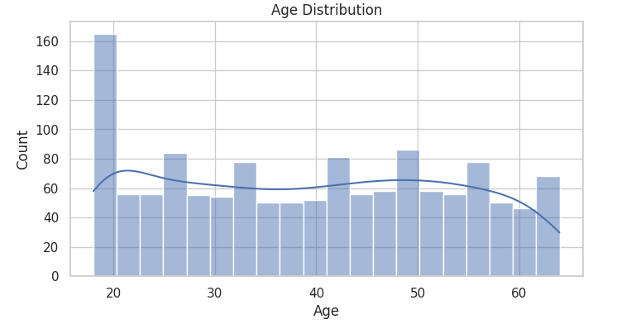

* + **Smokers** tend to pay **much higher premiums** for health insurance compared to non-smokers, which is consistent with the higher risk associated with smoking.

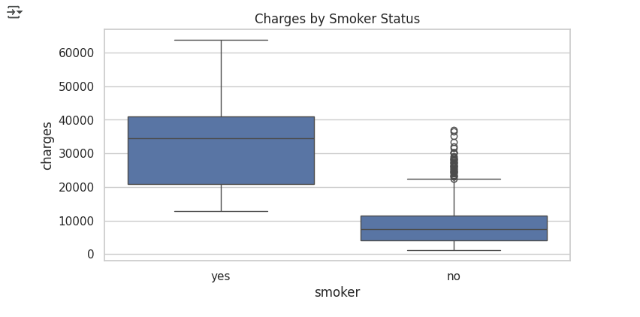

* + **Older customers** tend to pay **higher premiums** for **health insurance** as they likely present a higher risk to insurers.

1. **Body Weight and Insurance Premiums:**
   * There is a direct correlation between **higher body weight** and **higher insurance premiums**. This could be a reflection of the increased health risks associated with higher body weight.

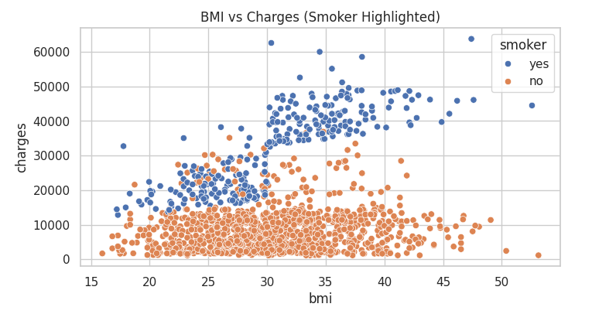

### **Car Insurance Preferences:**

1. **Gender and Car Insurance:**
   * **Men** are more likely to have **car insurance** compared to women. This may reflect differences in car ownership or driving habits across genders.

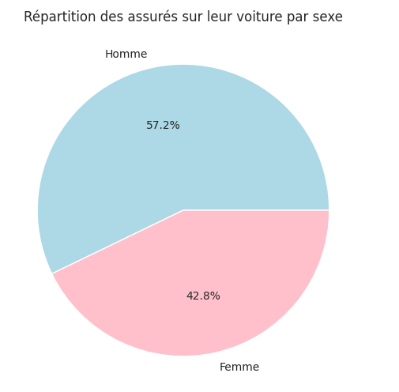

1. **Car Make and Insurance Likelihood:**
   * People who own **Toyota** cars are **much more likely to have insurance** compared to owners of other car brands. This could indicate brand-specific trends or preferences for certain car types that may correlate with insurance uptake.

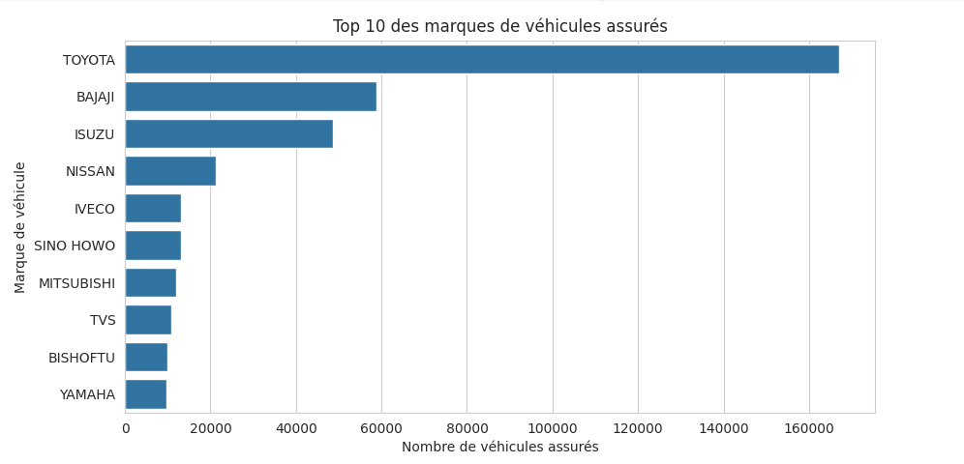

1. **Insurance Premiums for Cars:**
   * Customers tend to choose **lower premiums** for their car insurance. However, a small minority opt for a premium around **$5000**. This suggests that while most customers are cost-conscious, a few prioritize higher coverage or specific policy features.

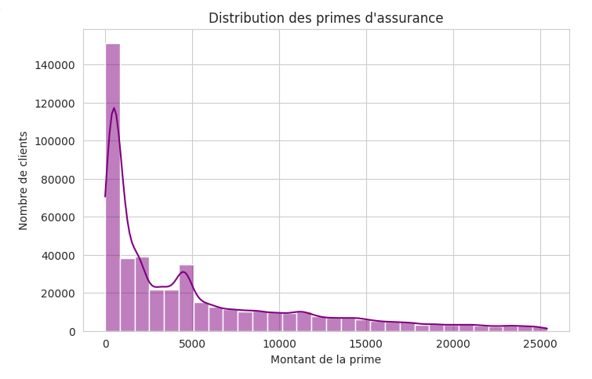

1. **Car Accidents and Seasonal Trends:**
   * **Car accidents** are **much more likely** to occur during **July and August**, which aligns with **summer vacation** periods when travel increases, leading to more vehicles on the road and potentially more accidents.

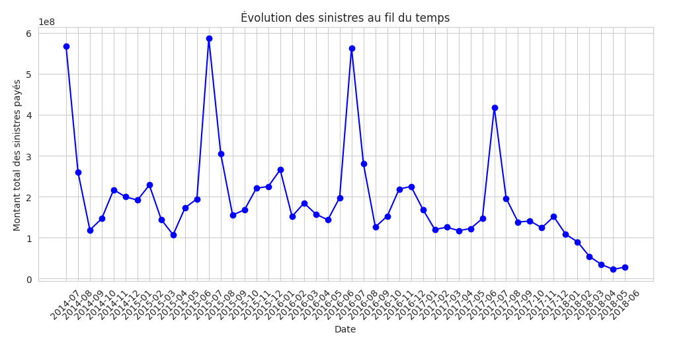

### **Public Sentiment and Airline Insurance:**

1. **Airline Sentiment Analysis:**
   * Among **American airlines**, **United Airlines** is the **most disliked**, reflecting a higher volume of negative sentiment.

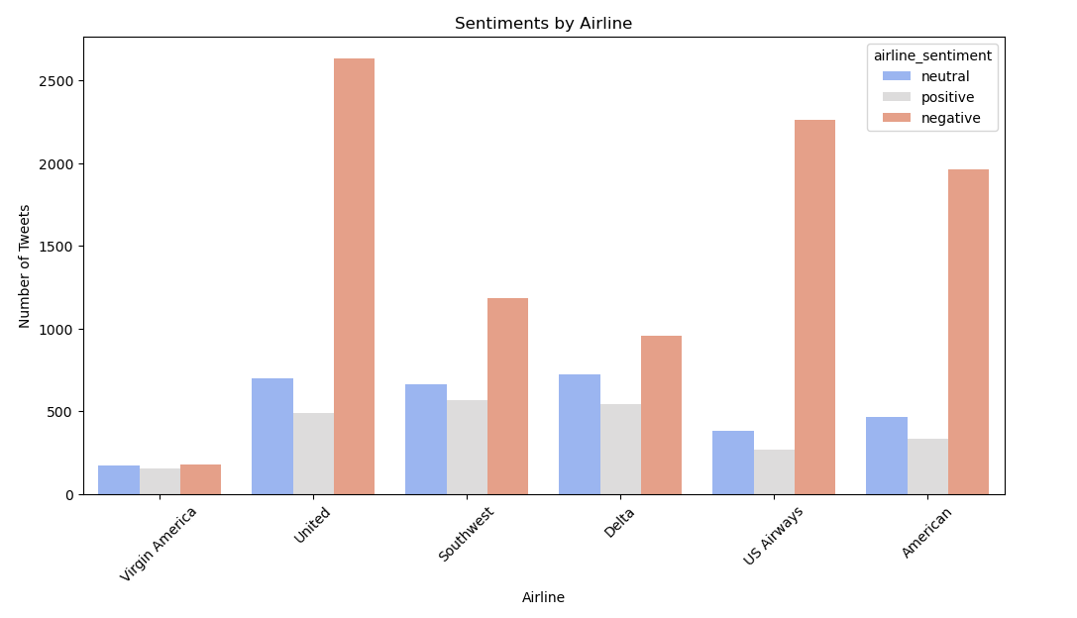

* + Among negative tweets, **common complaints** are related to:  
    - **Cancelled flights**
    - **Delayed flights**
    - **Customer service issues**

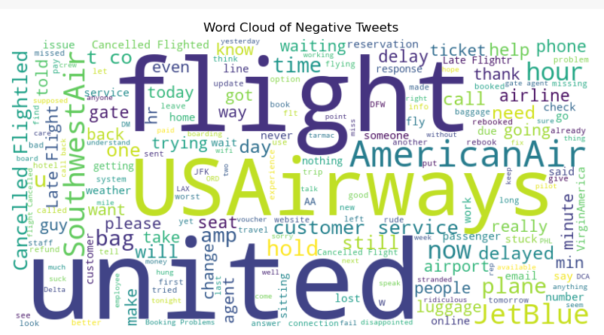

### **Environmental Trends and Sustainability:**

#### **Positive Correlations:**

1. **CO2 Emissions and Population:**
   * A **positive correlation** exists between **total CO2 emissions** and **population size**. Larger populations contribute to higher CO2 emissions, as expected due to more people driving, industrial activity, and energy consumption.
2. **CO2 Emissions and Emissions per Capita:**
   * A **positive correlation** also exists between **total CO2 emissions** and **CO2 emissions tons per capita**. This indicates that as total emissions increase, emissions per capita also rise, suggesting that higher population densities and larger economies might have a greater environmental footprint.
3. **Temperature and Climate Indicators:**
   * There is a **positive correlation** between **temperature change** and **average temperature** in Celsius. As the temperature changes, the average temperature naturally increases.
   * **Climate impact score** is positively correlated with:  
     + **Average temperature degree Celsius**: A higher climate impact score is linked with higher temperatures.
     + **Sea level rise (mm)**: Rising temperatures also contribute to higher sea levels.
     + **Extreme weather events**: As climate impact increases, extreme weather events (e.g., hurricanes, floods) become more frequent.

#### **Negative Correlation:**

1. **Renewable Energy and CO2 Emissions:**
   * A **negative correlation** is found between the **renewable-to-emission ratio** and **CO2 emissions tons per capita**, indicating that as the reliance on renewable energy increases, emissions tend to decrease.

### **Correlation Heatmap (Health Insurance Data):**

* The **heatmap** of correlations for the **health insurance dataset** reveals that factors like **age**, **smoking status**, and **body weight** have strong positive correlations with **insurance premiums**, whereas factors like **eco-friendly score** and **children count** show weaker correlations with premiums.
* Other correlations to look for:  
  + **Age**: Strongly correlates with higher premiums for both health and car insurance.
  + **Smoker vs Non-smoker**: Smokers tend to pay much higher premiums for health insurance, highlighting the role of health risks.

### **Key Insights and Business Implications:**

* **Sustainability and Insurance**: There is a clear trend where eco-conscious customers (often those with fewer children or younger demographics) tend to prioritize sustainability when choosing policies. LifeSure could tailor insurance products that focus on **eco-friendly policies** to attract this growing segment.
* **Health and Demographics**: Age, smoking habits, and body weight are crucial factors influencing health insurance premiums. Targeting policies based on age groups (e.g., younger people for medical insurance) or promoting wellness programs could help LifeSure create more targeted offerings.
* **Travel Insurance**: The spike in interest for **travel insurance** among those who have traveled abroad suggests an opportunity to design policies that appeal to frequent travelers. Furthermore, **age 28-34** seems to be a key demographic for travel insurance.
* **Car Insurance**: The preference for **Toyota cars** and **lower premiums** suggests that LifeSure may want to focus on lower-cost insurance policies for popular car brands while still offering comprehensive coverage to cater to customers looking for higher premiums.
* **Environmental Awareness**: There’s a positive correlation between **climate change indicators** (temperature rise, sea level increase) and **insurance trends**. This implies a market for **climate-conscious policies**. LifeSure could consider offering special insurance packages that support environmental efforts or incentivize sustainable behaviors.

on average, customers of a company are more likely to be 35-45 years old :



widows tend to spend more than other customers :



people around the age 30 – 50 are less interested in eco-friendly score than the average customer :



Customers with 0 children tend to be more carefull of eco friendly score than the average customer



Customers of the age 28 and 34 tend to be the most interested to travel insurance



people that already went abroad are more likely to buy travel insurances (ratio)



younger people (18-20) are more likely to have medical insurance



smokers pay much more than non smoker for health insurance



older people tend to pay more with age for health insurance

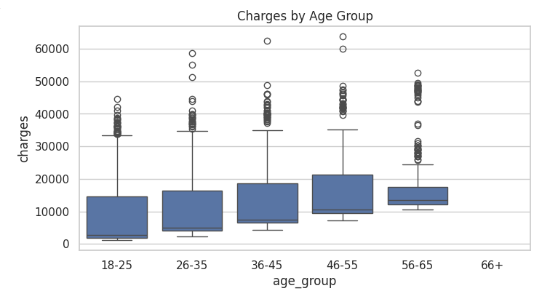

people with higher body weight tend to pay more



correlation heatmap for health insurance

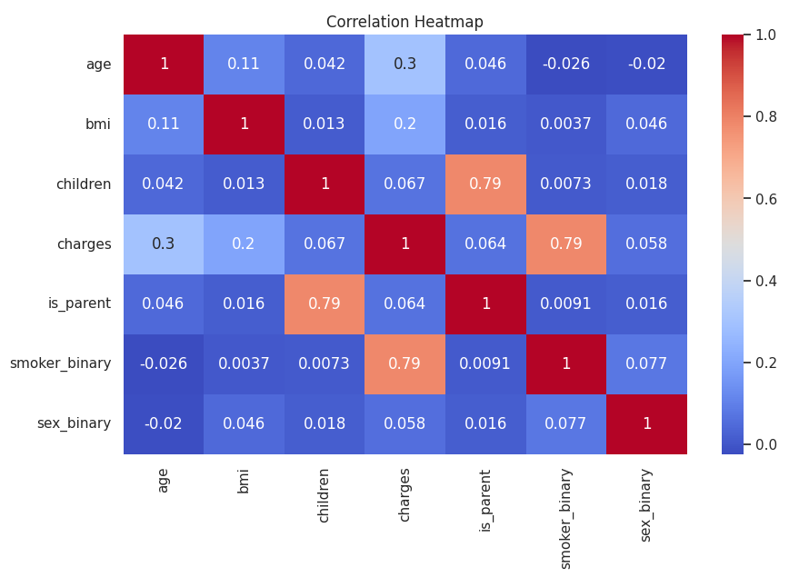

men tend to be more likely to have car insurance than women



people owning toyota cars are much more likely to have an insurance than others



people usually take lower insurance premium for their car, but a small majority is around 5000 as well



car accidents are much more likely during july and august (summer vacations)



among american airlines, united airline is the most unliked one



amongst negative tweets, we most often find complaints about cancelled flights, delayed flights and customer service.



ENVIRONNEMENT :

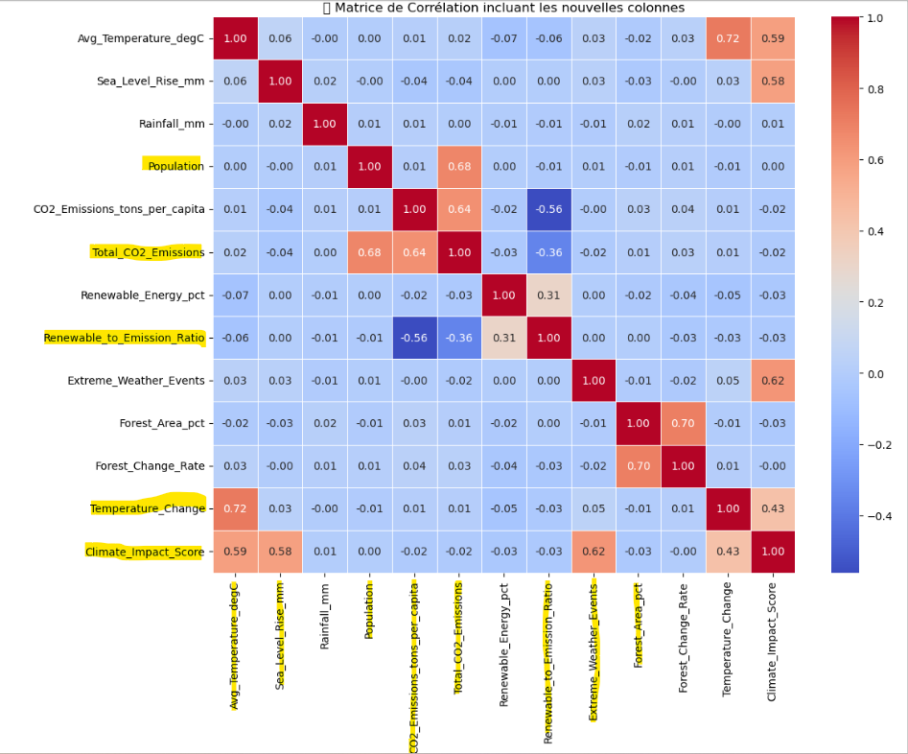

There is a noticeable positive correlation between :

* total CO2 emissions AND population
* total CO2 emissions AND CO2 emissions tons per capita
* temperature change AND average temperature degree celsius
* climate impact score AND average temperature degree celsius
* climate impact score AND sea level rise mm
* climate impact score AND extreme weather events

There is a noticeable negative correlation between :

* renewable to emission ratio AND CO2 emissions tons per capita

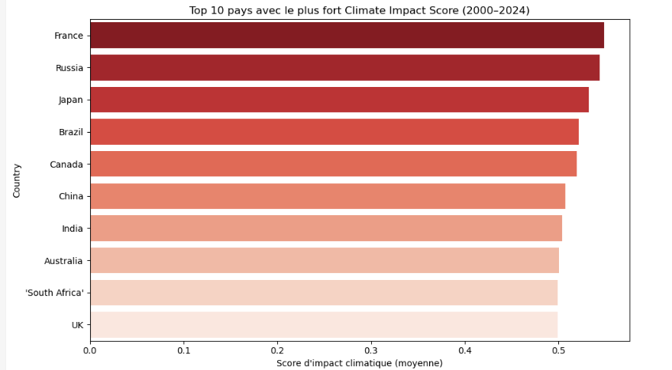

Ordered list of countries with the highest climate impact score : France, Russia, Japan, Brazil, Canada, China, India, Australia, South Africa, UK.

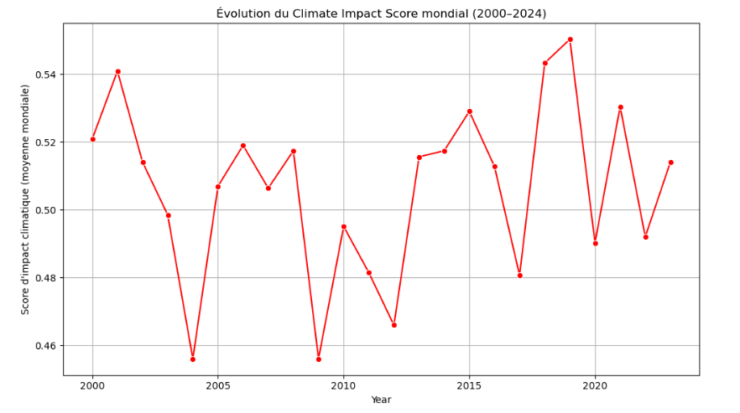

The chart shows fluctuations in the global Climate Impact Score from 2000 to 2024, with notable peaks and troughs indicating varying climate conditions. The highest score of approximately 0.54 occurred around 2000, 2005, and 2021, while the lowest points, around 0.46, were observed in 2003, 2012, and 2017, reflecting periods of both improvement and worsening climate impacts.

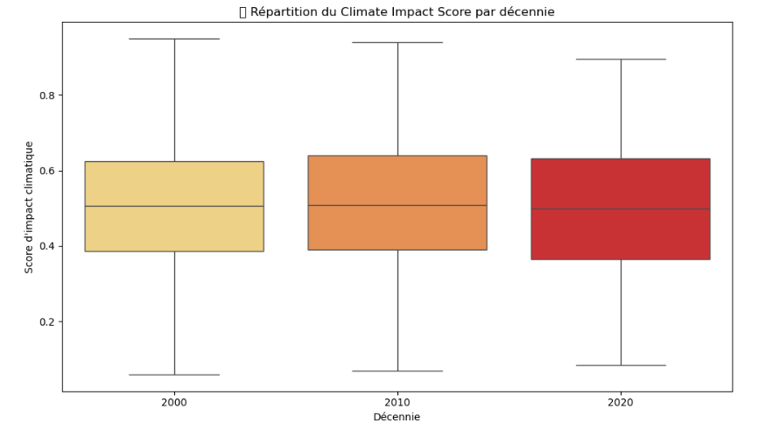

The box plot shows the distribution of the Climate Impact Score across three decades. The data reveals a slight increase in climate impact from 2000 to 2020, indicating a growing risk that could affect insurance premiums and coverage strategies. A higher score in recent years may signal increased climate-related risks for the company to consider.

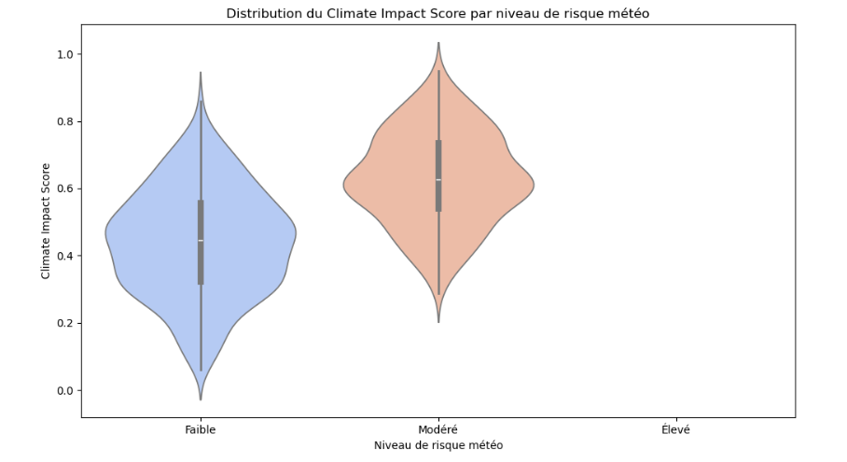

The violin plot illustrates the distribution of the Climate Impact Score across different levels of weather risk. It shows that areas with higher weather risk tend to have a higher Climate Impact Score, indicating a greater likelihood of extreme climate events. This suggests that insurance policies in high-risk areas may need to account for increased potential losses.